Task Assignment
Engineering Challenge – Line Racer

Sumo-Bot Match Procedures
- This will be a double-elimination competition.
- Each race will begin with a one minute “call to start” warning. Additional 30s and 10s warning will also be given. Teams unprepared to start on time will forfeit that race.
- This event will take place on a ~4’x4’ whiteboard placed on a waist-high table, with the course below marked out in 5/8 inch black electrical tape.
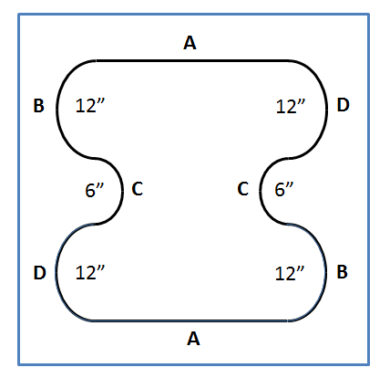
- The tape lines will be approximately 7 ½ inches from the edge of the whiteboard on all sides.
- The semi-circles at B and D have a 12 inch inner-diameter.
- The semi-circles at C have a 6 inch inner diameter.
- Racers will start opposite each other at a randomly assigned starting point (A, B, C, or D).
- The race will be two laps.
- One driver will escort the Line Racer as it travels around the table. While escorting the Line Racer, drivers must avoid contact with each other.
- The first Line Racer to cross its original starting position a second time wins. If one Line Racer catches up with its opponent, it will be declared the winner.
- Line Racers must follow the line at all times (no straight runs or fixed turns). A line following algorithm must be used at all times during the race.
- If a Line Racer “loses” the line, the student may pick up the robot and immediately restart it at the last starting point successful crossed (A, B, C or D).
- The wired-remote control may consist of one motor, structural components, and up to two sensors.
- At no time can the Line Racer be moved by pulling on the remote control wires.

Line Racer Specifications
Components: All robots will be constructed only from a single 9797 kit (items as listed on the 9797 placards) and the following additional allowed items:
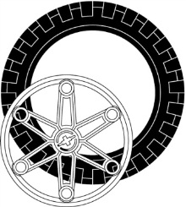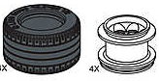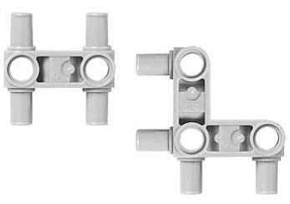

Large or Lawnmower Wheels (up to 2 each) Snap Beams (up to 8 each)
Size: All robots will fit inside a cube 12 inches on a side.
Exceptions: Liner Racers’ wired-remote controls may extend beyond 12 inches from the robot.
Power: All robots will be powered by a Lego rechargeable battery pack.
Design Modifications: Either hardware or software may be modified on the day of competition, provided the robot is ready to compete at its designated time.
Remote Control: Line Racers may use only wired-remote controls. In no case is wireless robot control allowed.

- Use the Engineering Process to develop your Line Racer.
  - The Commercialization step will be the Race.
- For each of the other steps of the Engineering Process, document your progress by completing the associated Deliverables and your Engineering Process Log.
- Have another team sign off on your deliverables before submitting them for grading (including all the elements for your Design Review).
- Present your Design Review for your classmates and teacher

Date | Deliverables | Sign-off
 | Problem Statement
 | Research
 | Design Plan
 | Prototype/Iterations
 | Commercialization
 | Successful Line Racer Design Review | (Teacher)

