Task Assignment
Engineering Challenge #3 – Sumo-Bots

Sumo-Bot Match Procedures
- This will be a double-elimination competition.
- Each match will begin with a one minute “call to start” warning. Additional 30s, 15s, and 5s warning will also be given. Teams unprepared to start on time will forfeit that match.
- This event will take place on a ~4’x4’ whiteboard with a black border. The arena will be a white square 36” on a side.
- Sumo-bot wrestling will begin with opponents in opposite corners and will continue until either one opponent is completely out of the arena, or one Sumo-bot is disabled.
- If, after two minutes, there is no clear winner the competition will be halted. After a second one minute “call to start”, an additional one minute re-match will begin. If there is no clear winner after the second match, both Sumo-bots move to the loser’s bracket.
- The winning robot must either push its opponent completely out of the arena, or disable its opponent (render opponent unable to maneuver, while victor Sumo-bot still can). If a robot is not pushed off the mat, but is flipped, the flipped Sumo-bot is considered disabled and loses the match.
Sumo-Bot Specifications
Components: All robots will be constructed only from a single 9797 kit (items as listed on the 9797 placards) and the following additional allowed items:
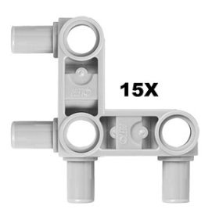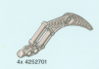
Large Wheel (up to 4) Angled snap Beam (up to 8) Claw (up to 4)
Size: All robots will fit inside a cube 12 inches on a side
Power: All robots will be powered by a Lego rechargeable battery pack
Software: All robots will be programmed by NXT-G.
Design Modifications: Either hardware or software may be modified on the day of competition, provided the robot is ready to compete at its designated time.
Page 1 of 2

Engineering Challenge #3 – Sumo-Bots

- Use the Engineering Process to develop your Sumo-Bot.
  - The Commercialization step will be the Sumo-Bot competition.
- For each of the other steps of the Engineering Process, document your progress by completing the associated Deliverables and your Engineering Process Log.
- Have another team sign off on your deliverables before submitting them for grading (including all the elements for your Design Review).
- Present your Design Review for your classmates and teacher

Date | Deliverables | Sign-off
 | Requirements
 | Research Report
 | Design Concept
 | Project Plan
 | Design Review Elements
 | SUCCESSFUL SUMO-BOT DESIGN REVIEW!! | (Teacher)
Page 2 of 2

