Task Assignment
“Line Following”
Team/Robot Name__________________________________________
Team Member’s Names______________________________________
As a team, work to develop the programs outlined below. Each of these completed programs must be demonstrated to one of the other teams. That team will then sign off indicating your program was successful.
Click on the last step, #11, and complete the RoboSlalom Challenge. When you have completed this challenge, have another team check it off before arranging with the teacher for your demonstration. Be prepared to discuss your Flow Chart, NXT-G program details and how you overcame any difficulties that arose.
Date | Program | Sign-off
 | Follow Straight Line for 15s (step #8)
 | Follow Straight Line Optimized for 10s (step #9)
 | Optimized to follow “S” Curve (step #10) ______(best time)
Date | Challenge | Sign-off
 | RoboSlalom Challenge
 | Successful RoboSlalom Challenge Completion!!!  Best time:________ | (Teacher)

Obstacle Course
Watch the Obstacle Course videos (NXT Video Trainer 2: Challenges) and review the Strategies to Solve Programming Problem document. Use these approaches to break down the challenge and development the program in increments. During your teacher sign off, be prepared to use your Flow Chart and comments in your NXT-G program to show how you tackled the challenge using these strategies.

Date | Challenge | Sign-off
 | Obstacle Course Challenge
 | Successful Obstacle Course Challenge Completion!!!  Best time:________ | (Teacher)

The Captain’s Buried Treasure, Part 3
Find this challenge under: NXT Video Trainer 2.0: Challenges: Additional Challenges.
Use the layout provided to develop and demonstrate your work. During your teacher sign off, be prepared to use your Flow Chart and comments in your NXT-G program to show how you tackled the challenge.
Date | Challenge | Sign-off
 | Successful Challenge Completion
 | SUCCESSFUL TREASURE HUNT (“X” marks the spot)!! | (Teacher)

Extreme Line Following
- This event will take place on a ~4’x4’ whiteboard with the line constructed of ¾” electrical tape. The course will include long straight-aways, curved turns, and sharp angled turns (see drawing below).
- Robots will begin at the starting “gun” (wooden clapper) and their time over the course will be recorded when they come to a stop after touching the stop-block.
- Robots must continuously use a light sensor to follow the line, but may use any other sensor(s) to supplement performance.
- No external stimuli may be supplied during the run.
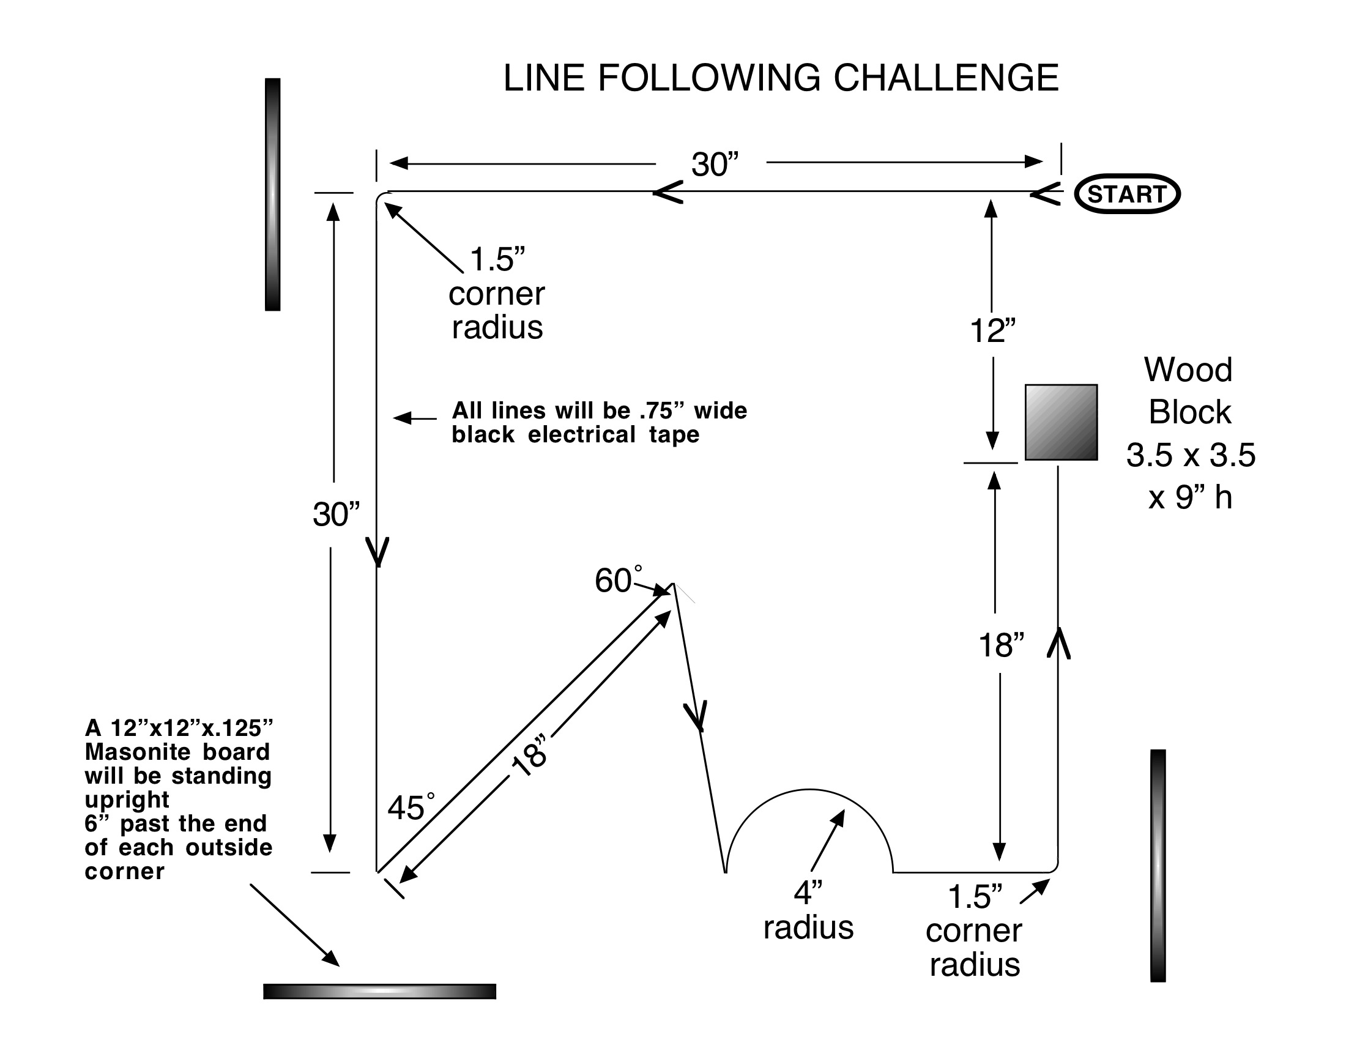
Use the layout provided to develop and demonstrate your work. During your teacher sign off, be prepared to use your Flow Chart and comments in your NXT-G program to show how you tackled the challenge.
Date | Challenge | Sign-off
 | Successful Challenge Completion
 | SUCCESSFUL TREASURE HUNT (“X” marks the spot)!! | (Teacher)

