Task Assignment
Motor Blocks
Team/Robot Name__________________________________________
Team Member’s Names______________________________________
The Motor Block is located in the Complete Palette, under the Action Menu. The NXT-G programming block and configuration panel for the Motor Block are shown below:
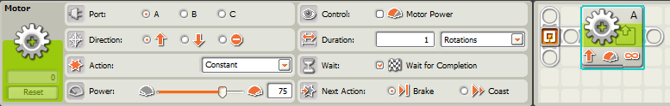
Your assignment requires you to teach yourself all the features of the Motor Block and develop a Robot which takes advantage of the Motor Block’s capabilities.
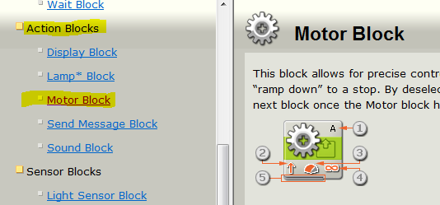
Research
The NXT-G program has a very thorough set of “Help” files. Click on the “?” tab near the lower right corner of NXT-G window to open the Help system. On the right hand side of the Help window, scroll down the Action Block section and select the Motor Block help item.
Study the details of the “Configuring the Motor Block” section in the help (note: you are not responsible for the “Configuring the Motor Block’s Data Hub” section of the help file at this time). Rewrite your Maze Challenge program (from “Turning” lesson) to use Motor Blocks instead of Move Blocks. Have another team check it for accuracy, before arranging with the teacher for your demonstration. Be prepared to discuss your pseudocode, your program, and explain at least four advantages/disadvantages of using the Motor Block (versus the Move Block) to control Tribot movement.
Date | Program | Sign-off
 | Motor Block Maze
 | SUCCESSFUL MOTOR BLOCK MAZE COMPLETION!! | (Teacher)
Page 1 of 2
Third Motor Challenge
1.) Add a third motor (Motor A) to your Tribot.
2.) Build an attachment of your choice onto Motor A that performs some function.
3.) Write a program for your modified Tribot which demonstrates the functionality you have added.
4.) Your program must use the Motor Block to control Motor A.
5.) The demonstration of your modified Tribot must include the Tribot moving using the Move Block to control Motors B & C.

When you have completed this challenge, have another team sign off on your modified Tribot functionality, before arranging with the teacher for your demonstration. Be prepared to discuss the functionality you added, your pseudocode and program, and the hardware/software tradeoffs you made in your design.
Date | Challenge | Sign-off
 | Third Motor
 | SUCCESSFUL THIRD MOTOR CHALLENGE COMPLETION!! | (Teacher)

Page 2 of 2

