- What happens if you change a Line Follower’s Loop Control Method to Time? Propose one possible use for this modified behavior.
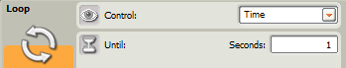
- Besides time, what are 3 other ways to
control a Line Follower’s Switch-Loop?
- Explain the role of the Switch Block in a Line Follower’s Switch-Loop.

- What is the difference between Basic Line Following and Optimized Line Following? How do you implement both in NXT-G?
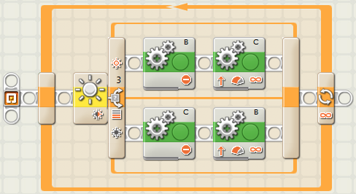
- Ziffle writes this Line Follower program to track a gently curving line. Much to everyone’s surprise, Ziffle’s program works quite well. Ziffle must now modify this program to work on two other courses. How should Ziffle modify his program to:
A) maximize speed on a straight course?
B) track a course with much sharper curves?

