Use the figure below to help answer the following questions
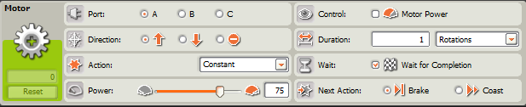

- Describe the function of each of the 8 parameters in the Motor Block:
A) Port:
B) Direction:
C) Action:
D) Power:
E) Control:
F) Duration:
G) Wait:
H) Next Action:
- Describe a situation where you might want to change the Action parameter to a selection other than “Constant”. Why?
- Describe a situation where you might want to select the “Motor Power” option in the Control parameter. Why?
- Explain four advantages or disadvantages of using the Motor Block (versus the Move Block) to control a Tribot’s movement.

