- Why is a sound sensor mounted so high on a tribot?
- The starting gun registers 100 on the sound sensor while the quiet crowd registers 24. What should the sound sensors threshold be set at? Show your work.
- This “Clap-on, Clap-off” program uses a sound threshold >50 for the first Wait-until-Sound block (as shown) and <50 for the second Wait-until-Sound block (not shown) . Explain why this program may not work as intended.
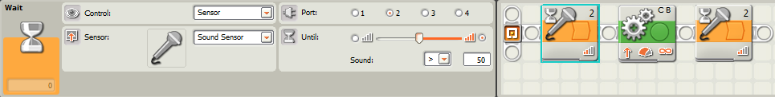
- Ziffle then writes a program that will wait for the lights in the room to turn back on and have the tribot drive forward out of its corner in the room and stop as soon as it hears a clap within the first minute. Ziffle sets the light and sound thresholds correctly, but once again is surprised and disappointed by the results. What happens when Ziffle tries the program? What needs to be changed to get the desired results?
