- How do you know which branch is Near and which is far Far in an Ultrasonic Sensor controlled Switch Block?
- Is the Switch-Loop “special” in the Programming Software? For an Obstacle Detection program, what does the Switch-Loop do, and how does it do this?
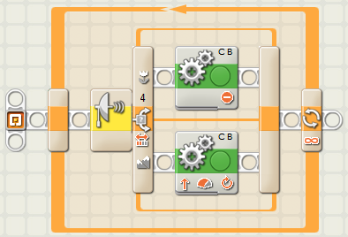
- Ziffle writes this straight line Obstacle Detection program. What happens when the program is run? What does Ziffle need to do to improve it? Why?
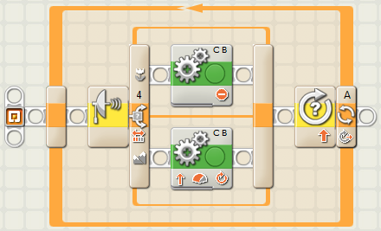
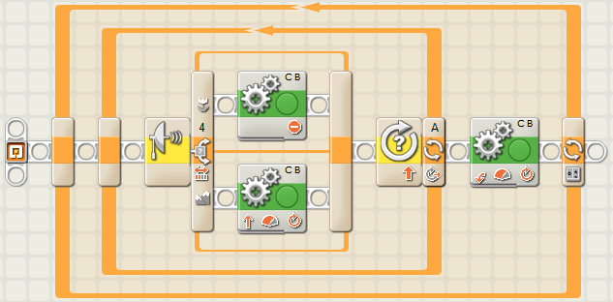
- Ziffle fixes the previous problem with his Switch-Loop (not shown) and changes the Loop Control to “10 Rotations”. Assuming Ziffle fixed the previous problem, what happens when he runs this new program. Why?
- Ziffle fixes both previous problems with his Switch-Loop (not shown), then he adds a 90 degree turn and an outer Counter Controlled Loop so the tribot will travel in a square. Assuming Ziffle fixed the previous problems in his Switch-Loop, what happens when he runs this new program. Why?

