Quiz
Taking Turns
Name:_________________________ Period:___ Date:________ Score:_____/30

Use the figure below to help answer the following questions
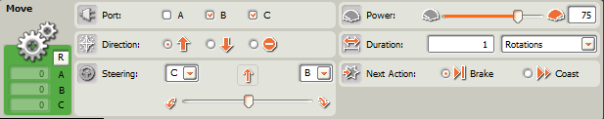

- (3 pts.) What is a point turn and how do you implement one with Move Blocks?

- (3 pts.) What is a swing turn and how do you implement one with Move Blocks?
- (3 pts.) What is a U-turn and how do you implement one with Move Blocks?
- (2 pts.) Ziffle writes a program to have his robot make a 90 degree point turn to the right. Ziffle sets all the Move Block parameters properly to make a right turn and sets the Duration parameter to 90 degrees. Ziffle is disappointed to discover that his robot only turns about 60 degrees. Why did Ziffle not get the expected result?
- (3 pts.) Describe three methods Ziffle could use to determine the correct parameters for the Move Block in question 4.

Use the figure below to help answer the following questions
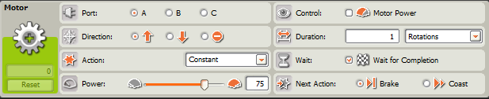

- (8 pts.) Describe the function of each of the 8 parameters in the Motor Block:
A) Port:
B) Direction:
C) Action:
D) Power:
E) Control:
F) Duration:
G) Wait:
H) Next Action:
- (2 pts.) Describe a situation where you might want to change the Action parameter to a selection other than “Constant”. Why?
- (2 pts.) Describe a situation where you might want to select the “Motor Power” option in the Control parameter. Why?
- (4 pts.) Explain four advantages or disadvantages of using the Motor Block (versus the Move Block) to control a Tribot’s movement.

