Introduction to Programming
Lego Mindstorm EV3
Decisions: Line Follower 1-2 (found online in Robotics Academy EV3)
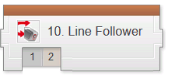
❐ Watch: Line Follower 1: Introduction to Automated Material Transport System (AMTS)
What environmental feature will the robot use to help it navigate in this challenge?
- A line on the ground
- IR beacons on walls
- Volume levels of environments
- It is facing Northward

What programming concept will be used to create this behavior?
- Discrete behaviors
- Multitasking
- Repeated decisions
- Bad decisions

❐ Do: Robot Configuration (Color Sensor – Facing Down)

❐ Watch Line Follower 2: Challenge (Line Tracking)

If the robot is seeing Black, what can it tell about its position?
- It is over the line
- It is outside the line to the left
- It is outside the line to the right
- It is facing Northward

Page 1 of 2
Suppose the robot is tracking the left edge of the line, and sees Black. Which way should it move?
- Forward and to the left, because the left edge is that way
- Forward and to the right, because the left edge is that way
- Straight forward because the line will curve eventually
- Turn left in place, because the left edge is that way

Which basic program pattern is being used in this Line Tracking behavior?
- Sequential Movements
- Parallelism
- Repeated Decisions
- Variables
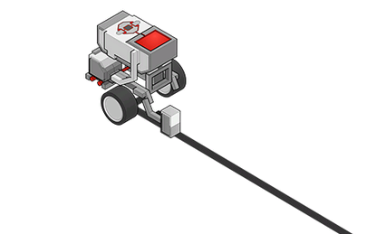
❐ Do: Mini Challenge: Track Line for Rotations
Program the robot to stop line-tracking after moving for four rotations.

❐ Show Teacher _________
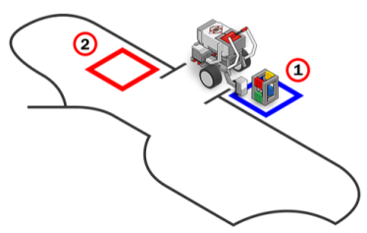
❐ Do: Challenge In this challenge, you will program your EV3 robot to grab a cargo crate from the pickup spot, follow the line track and drop the crate off in the drop-off zone.

❐ Show Teacher _________

❐ Document Mini Challenge & Challenge (include pictures and detailed descriptions of program function and robot behavior)
Page 2 of 2

