Introduction to Programming
Lego Mindstorm EV3
Behaviors: Turning 1-5 & C (found online in Robotics Academy EV3)
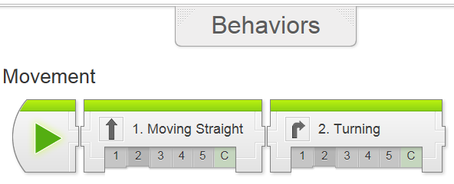
Check the boxes ✓ as you finish each task.
❐ Watch Turning 1: Introduction with Crop Tractor
1. Why is it important to be able to drive through an orchard?
- To perform specialized tasks to different types of crops
- GPS is required while navigating around the orchard
- To perform tasks like inspection and spraying which cannot be done as effectively through other means
- All of the above

2. What is the advantage of the Autonomous Tractor over a human driver?
- Reduces the need for humans to perform the repetitive task of driving through the orchard over and over
- Reduces exposing human to hazard areas while performing inspections
- Autonomous Tractor can travel through an area where a human driver may get lost
- There is no big advantage

3. In addition to basic turning, what additional, new knowledge will help you complete this challenge?
- How a robot moves straight
- How a robot move back and forth
- How a robot turns, and different types of turns
- All of the above

❐ **Go through a kit inventory of parts and document on form. (use new inventory form)
❐ Turning 2: Robot Config (build EV3 driving base)

❐ Watch Turning 3: Turning in Place (Name your new project, “LastName_TURNS”)

1. What does the robot do when the Turn Right program is run?
- Move straight forward
- Spin to the robot's right without moving forward at all
- Spin to the robot's left without moving forward at all
- Spin for 360 degrees

2. TRUE or FALSE: With "Rotations" on the Move Steering Block to 1, the whole robot rotates 1 time.
TRUE: the robot will turn around 1 time
FALSE: the wheels will turn 1 time, not the body

❐ Do Mini Challenge 1: 90 Degree Turn
❐ Observed by teacher ______________
❐ Add new slide in “Program Documentation” titled TURNS and add screen shot and description of program (90° Turn)

Try It! #1: Direction of Turn
Moving the Steering slider all the way to the right makes the robot turn to the right, in place. What happens if you move it all the way to the left?

The white pointers on the EV3's tires help you to see how much the wheels are rotating. Run your Turn Right program again, and watch the pointer on the robot's right wheel.

3. How much did the robot's wheel turn during this movement?
- 1 rotation
- 1 degree
- Enough to make the robot spin completely around one time
- One lap around the table
pg. 2
4. What does the "1 rotation" refer to in the Move Steering Block's controls?
- 1 full rotation of the robot's body during a turn
- 1 rotation of the robot's wheels
- 1 time that the robot is picked up and turned around
- 1 rotation of the Earth and its axis

❐ Watch Turning 4: Other Turns

1. In the movement you programmed, the left motor was told to move forward at 50% power, and the right motor was told to...
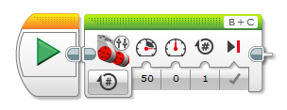
- Move forward at 50% power
- Move backwards at 50%
- Stay in place
- Spin freely

2. What kind of turn did the robot produce with one motor running and one motor stopped?
- Goes straight
- Turns in place
- Turns "wide"
- Backs up

❐ Do Mini Challenge 1: Dizzy Drill
Program your robot to run out to an obstacle, go around it, then come back. Use a small object as an obstacle, and program your robot to travel around it. The robot may start and finish in any position behind the start line.
pg. 3
❐ Dizzy Drill Observed by teacher __________
❐ Add to Program Documentation (Dizzy Drill w/screen shot and description)

Try It! #1: Different Motions
You can create many different type of motion by combining different motor speeds. Try each of the following to see what you get!
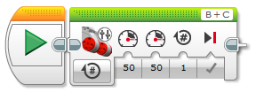
What happens?

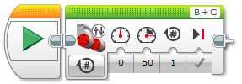
What happens?

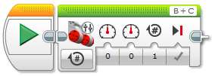
What happens?

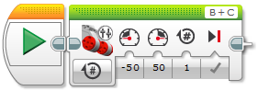
What happens?
pg. 4
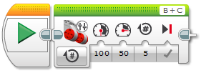
What happens?

Turning 5: Turning Review

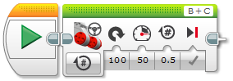
What is the programming blocks name?
How does the tribot behave with this program?

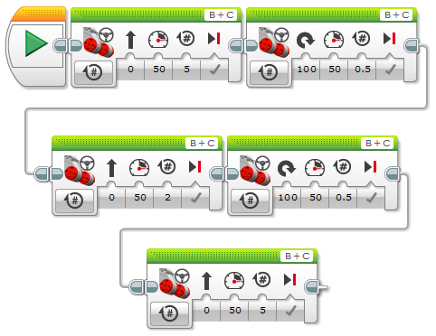
How does the tribot behave with this program?

pg. 5
pg. 6
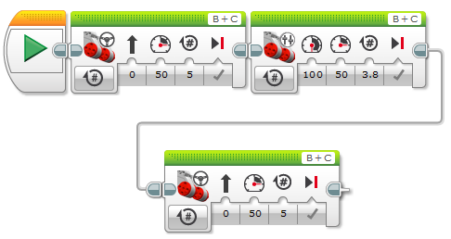
How does the tribot behave with this program?

❐ Do Turning 6: Orchard Challenge (fill in which challenge(s) you completed. You must complete a minimum of 2 challenges)
❐ Challenge #____ Observed by teacher
❐ Challenge #____ Observed by teacher
❐ “Program Documentation” (Orchard Challenge)

Upon completion of the Behaviors-Turning module 1-5 & C, you should have the following programs in a project titled “LastName_TURNS” (you should also update your program documentation file with a new slide titled TURNS containing the programs and description for each maneuver):
❐ Turning in place clockwise 90 degrees (TurnRt)
❐ U-Turn around an obstacle (Dizzy Drill)
❐ Orchard Challenge (Orchard #__, Orchard #__, where __ = number)

You may also want to add program documentation of the following:
❐ Swing wide turn counter-clockwise (TurnLtWide)
❐ Swing wide turn 90º (TurnWide90)
❐ Swing wide turn 360º (Turn360)

