Introduction to Programming
Lego Mindstorm EV3
Behaviors: Sensors – Turn For Angle 1-5 & C
(found online in Robotics Academy EV3)
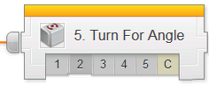
Check the boxes ✓ as you finish each task.

❐ Watch Gyro 1: Introduction to Golf Course Mower
1. What does a gyro sensor help the robot to do?
- Move a precise distance
- Turn more precisely
- Use GPS
- None of the above

2. Why does the autonomous mower use a gyro sensor if it already has GPS?
- Gyro sensor is more accurate than GPS
- GPS is sometimes blocked or unavailable
- GPS can be slow sometimes
- Robot moves faster using gyro sensor

3. Why should your robot use a gyro sensor even if it already has rotation sensors?
- Wheels sometimes slip and lose accuracy
- Wheel's rotation sensor cannot be used to detect body rotation
- Gyro sensor works independently from GPS
- All of the above

Page 1
❐ Do Gyro 2: Robot Configuration
Configure Gyro Sensor to Robot per instructions.

❐ Watch Gyro 3: Turn for Angle (Part 1)
1. Because of the way it is attached to the robot, the Gyro Sensor measures:
- The amount the robot's body turns
- The amount the robot's wheels turn
- The amount the robot is "tipping" forward or backward
- When an oscilloscope is nearby

2. When the robot actually ran, what happened?
- The robot turned its body exactly 90 degrees
- The robot turned its body slightly more than 90 degrees
- The robot moved forward 90 degrees
- The robot spun in place forever

❐ Watch Gyro 4: Turn for Angle (Part 2)
1. Which of the following factors contributes to the "overturning" problem?
- Sensor accuracy limitations
- Delay in sensing and signal transmission
- Physical momentum
- All of the above

2. Which of the following workarounds can help to reduce the "overturning" problem?
- Replace the Gyro sensor
- Telling the robot to wait until a value that comes "before" the one you actually want
- Use a different numbered port
- Press the cancel button as soon as it completed its turn
Page 2

3. What is the difference between a workaround and a solution?
- A workaround is preferred over a solution
- A solution removes the source of the problem, while a workaround only reduces its effects
- A workaround removes the source of the program, while a solution only reduces its effects
- None, as both are equally the same

❐ Do Try It! Try it! 1 Left Turns
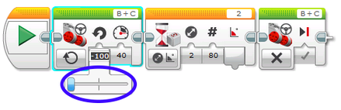
Does the same Wait for Gyro block work for left turns?

Try changing your program to turn 90 degrees to the left instead.
What happens?

❐ Do Mini Challenge 1: Square Box Observed by teacher ____
Program and make the robot complete a full lap around a square box, using the Gyro Sensor to control all of its turns.
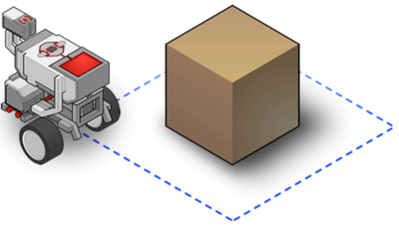

❐ Watch Did you know? How the Gyro Sensor Works
Page 3
❐ Do Gyro 5: Gyro Sensor Review
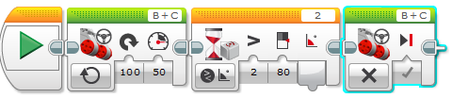
- Provide a detailed explanation of how the following program will run.

- Provide a detailed explanation of how the following program will run & how the robot will react.
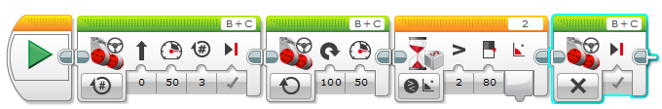

❐ Gyro 6 : Watch Mower Challenge
❐ Modify Robot for Scoop/Eraser Attachment (check with teacher)
❐ Do Mower Challenge Observed by teacher __________

Upon completion of the Behaviors-Turn for Angle module 1-5 & C, you should have the following programs in a project titled “LastName_GYRO” (you should also update your program documentation file with a new slide titled GYRO SENSOR containing the programs and description for each maneuver):
❐ Gyro Sensor Mini Challenge Around Square Box
❐ Gyro Sensor (with Scoop/Eraser) Mower Challenge
Page 4
Page 4

